—----------------------------------------------------------------------------------------------------------------------------Website QA Review: Home Page
Reviewed: Aug 5, 2026 | Reviewer: Aparna | Source of Truth: TBG_Website_Content_Architecture doc
Live URL: https://tbz-web.vercel.app/
Status: Draft for Aparna's review → then share with Paige - Niharika

Summary
Severity | Count
🔴 Critical (blocks launch) | 4
🟡 Important (fix before Paige review) | 4
🟢 Minor (polish) | 2
Overall finding: The page structure (section order, scroll layout, three-path cards, principles, closing CTA) is correct. The content filling those sections is almost entirely wrong. The developer appears to have used AI-generated placeholder copy instead of pulling from the spec doc. The entire page needs a content pass using spec copy verbatim.

🔴 Critical Issues

1. Hero Section: Headline & Subhead Off-Spec

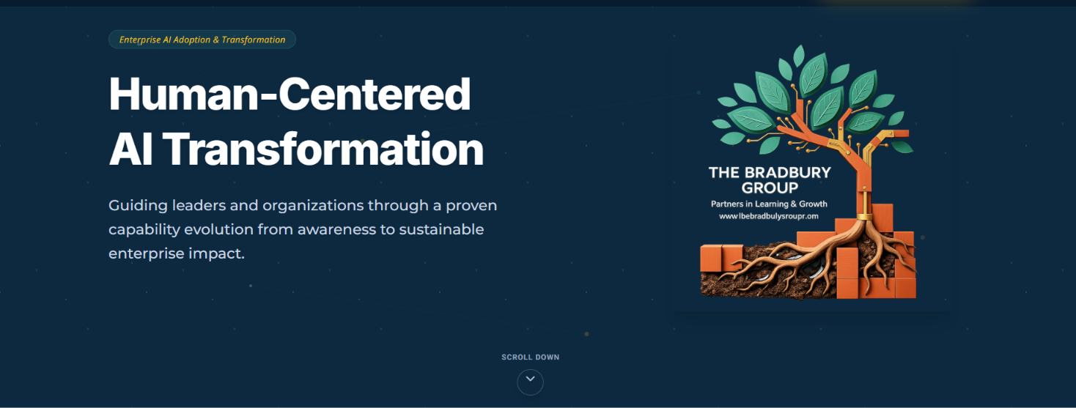
What's live:
"Human-Centered AI Transformation"
"Guiding leaders and organizations through a proven capability evolution from awareness to sustainable enterprise impact."
What it should be:
Headline
Option C: "Stop Implementing AI Tools. Start Architecting Human Performance" or
Begin Building Human Performance with AI or Start Architecting Human Performance with AI.

At TBG we create the AI Systems that Empower Human Performance and assist in Strategic upskilling and reskilling the workforce

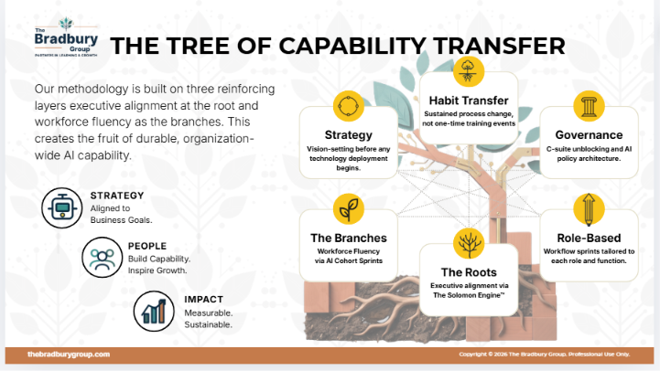

2. "Meet Columbus" Section Entirely Missing

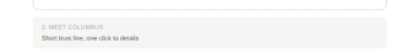

What's live: Nothing. Page jumps straight from Hero to Carousel. And, it is just placed in the corner bottom. It was asked to be placed like a SCROLLING WIDGET.
What should be here:
Columbus is our AI assistant. It'll ask a few questions about what you're looking for, and our team follows up personally. No bots deciding anything, no automated sales pitch. Full details on how it works are one click away.

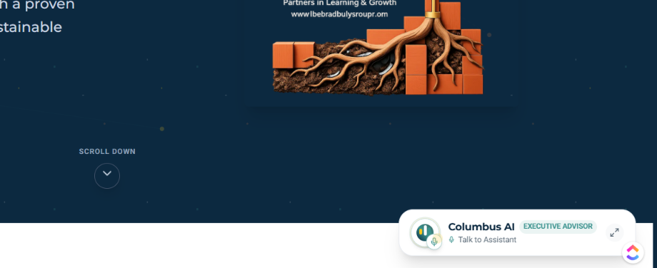

What’s Moving? TBG & Industry Updates.

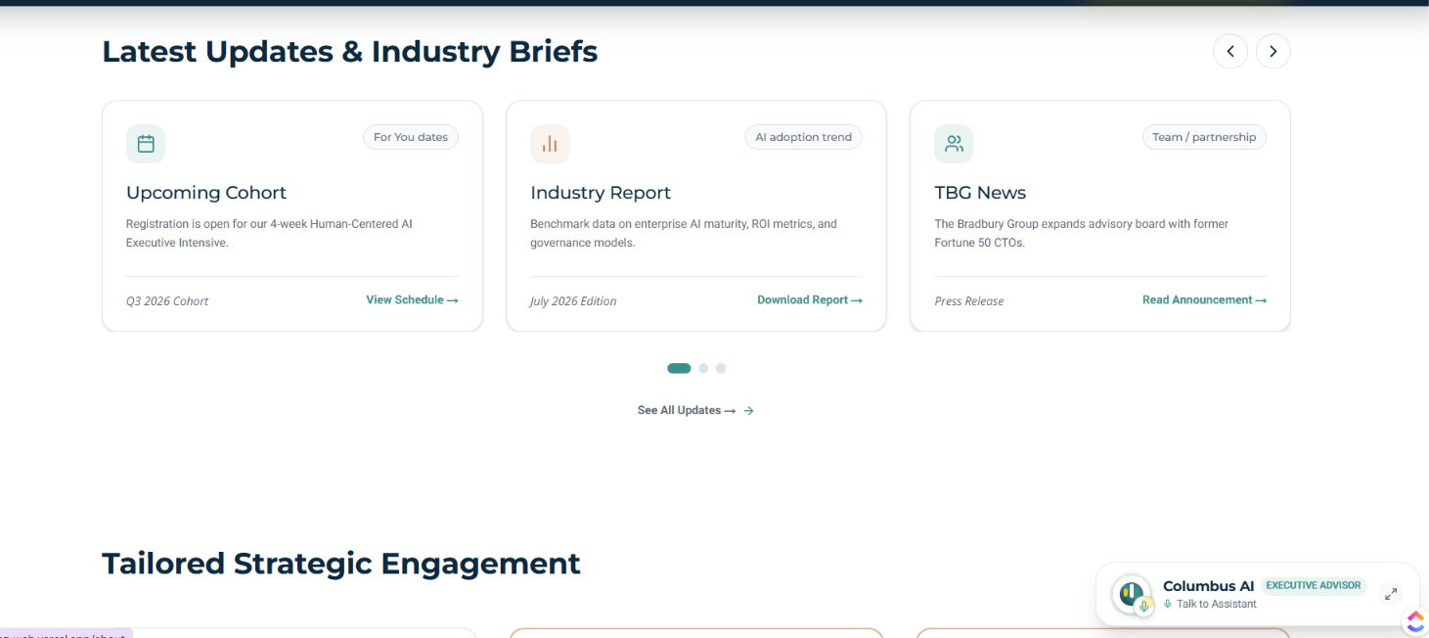

This UI and the below UI(3 Paths Section) are almost the same. It is good we bring some difference to improve relatability/identity and engagement.

What's live (WRONG):

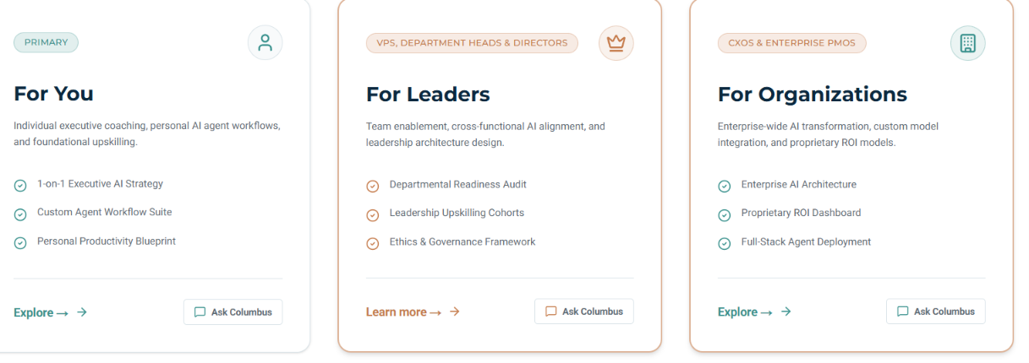
- "Tailored Strategic Engagement" header
- Card 1: "For You" listing "Custom Agent Workflow Suite", "Personal Productivity Blueprint"
- Card 2: "For Leaders" listing "Departmental Readiness Audit", "Leadership Upskilling Cohorts"
- Card 3: "For Organizations" listing "Proprietary ROI Dashboard", "Full-Stack Agent Deployment"
- Audience labels: "VPs, Department Heads & Directors" / "CXOs & Enterprise PMOs"
These products do not exist at TBG. This is a credibility risk if seen externally.
Replace with:
Section headline:
Already Know What You Need? Explore Directly.
Card 1 (larger, primary):
For you: Build Your Own AI Fluency
A structured program for individual professionals. Practical skills, real frameworks, built for sustainable professional leverage.
CTA: Explore AI Fluency Cohort →
Card 2:
For Leaders: A Strategic Partner for Executives
A private, one-on-one engagement for leaders who need to build an AI strategy they can execute with confidence.
CTA: Learn About The Solomon Engine → Talk to Solomon AI
Card 3:
Bring AI Fluency to Your Team
Training, learning architecture, and community workshops built for organizations who want to roll out AI at scale.
CTA: Explore Organizational Partnerships → Contact Us

Remove all audience labels ("VPs, Department Heads", "CXOs & Enterprise PMOs"). Remove all "Ask Columbus" CTAs from cards.

🟡 Important Issues

5. "How It's Different" Section: Close but Rewritten
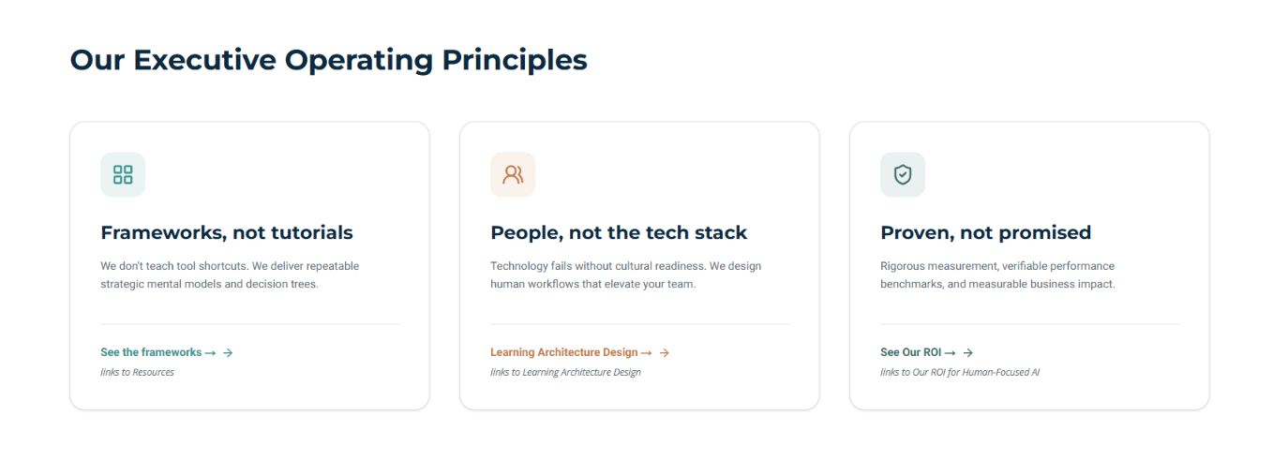
What's live:
"Our Executive Operating Principles"
"Frameworks, not tutorials: We don't teach tool shortcuts. We deliver repeatable strategic mental models and decision trees."
"People, not the tech stack: Technology fails without cultural readiness. We design human workflows that elevate your team."
"Proven, not promised: Rigorous measurement, verifiable performance benchmarks, and measurable business impact."
Replace with:
Built on structure, not screenshots.
We explore how to think with AI, not which buttons to click.
CTA- TBD
People-first.
Every learning journey starts with how people actually learn and adopt new skills. Not just the tools themselves.
CTA-TBD
Proven, not promised.
Every framework we use has been vetted and tested with real clients.
CTA- See out ROI ( Can be routed to ROI Page)
Remove "Our Executive Operating Principles" title. Either no title or something lighter.

6. Closing CTA Section: Too Corporate
[SCREENSHOT: Bottom CTA section]
What's live:
"Schedule a confidential 30-minute strategic consultation with our executive team."
"Confidential 30-minute strategic consultation with our senior executive team."
Replace with:
Not Sure Which Path Is Right for You?
Talk it through with us directly.
CTA: Book a Discovery Call →
Link to: Google Calendar booking (Discovery & Alignment Call, $50 credited)

7. Columbus Widget Mislabeled
[SCREENSHOT: Columbus widget in corner]
What's live: "Columbus AI / EXECUTIVE ADVISOR / Talk to Assistant"
Replace with:
- Label: "Columbus" (just the name)
- CTA: "Chat with Columbus" or "Start here"
- Remove "EXECUTIVE ADVISOR" entirely. Columbus is a friendly qualifier/router, not a decision-maker. The whole point is Paige reviews everything personally.

8. Audience Labels Don't Match TBG Language
What's live: "VPs, Department Heads & Directors" / "CXOs & Enterprise PMOs"
Action: Remove entirely. TBG doesn't use corporate title soup. The content architecture refers to "individual track", "executive track", and "org-buyer track" but these aren't meant to be rendered as audience labels on the page.

🟢 Minor Issues

9. Carousel Uses Fake Announcements
Content to be replaced.

10. "See All Updates →" CTA Destination Undefined
Where: End of carousel section
Issue: Likely links nowhere. Should route to the Insights page once live. Low priority for now but needs a routing decision before launch.

Designer & Dev Instructions (for Shashank)
- Do NOT use AI-generated placeholder copy. Pull all text directly from the content architecture doc.
- Each section's exact copy is provided above. Use it verbatim.
- Where ⚠️ appears, leave that section as an obvious placeholder until Paige decides.
- Columbus widget: simplify label and CTA per notes above.
- Remove all fabricated product names and audience labels.

